**Verification Plan for MHMessenger Application**

**MySQL Minor Version Upgrade from 8.0.27 to 8.0.28**

* Check - application is up & running.

As soon as we received the mail from the respective team, asking us to validate the application after the patching activity is over, go to the deploymanager link for this application.

<http://3mobapp.mas.net:8080/Deploymanager/html>

Enter the username and password

**Username: tomcatusr**

**Password:** MN7XwPFd

Now click on /mhmessenger. Login page will be visible for this app.

Now you can login and move forward with the verification of application.

Simultaneously capture the artifacts for proof.

* Artifacts:

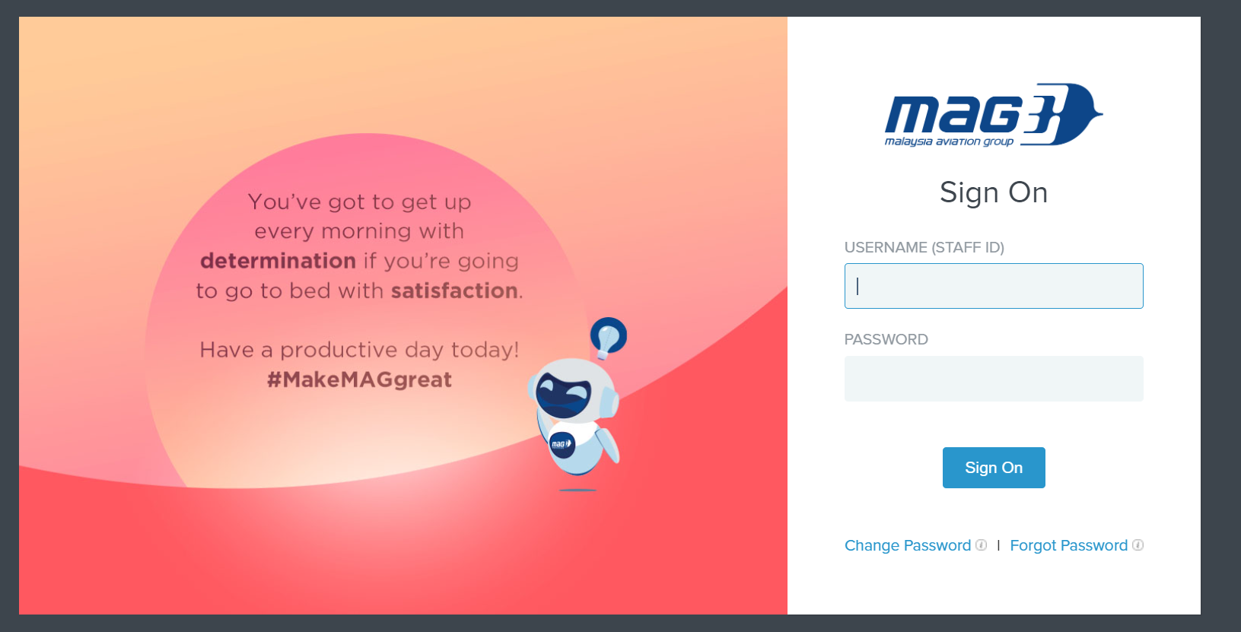

* Application Login is working fine.

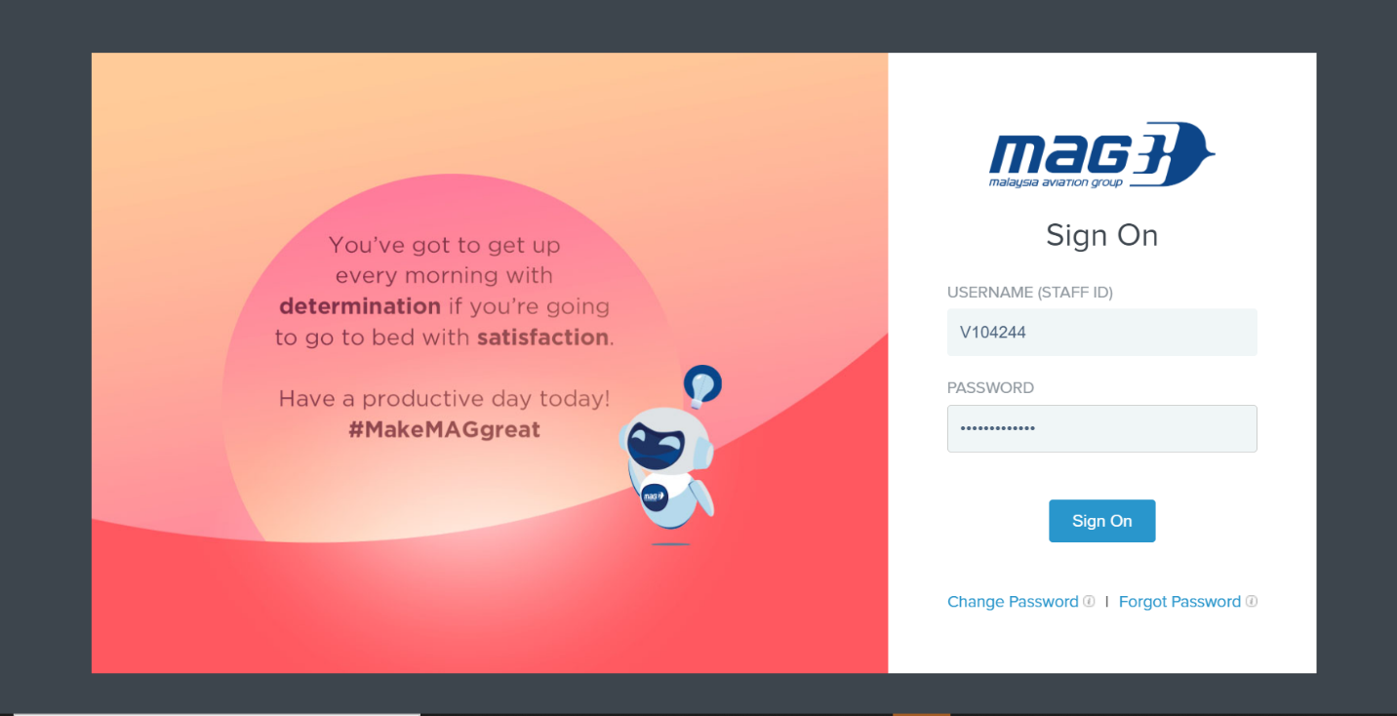

* Released functionality./Basic functionality.
* Home page - after login is successful

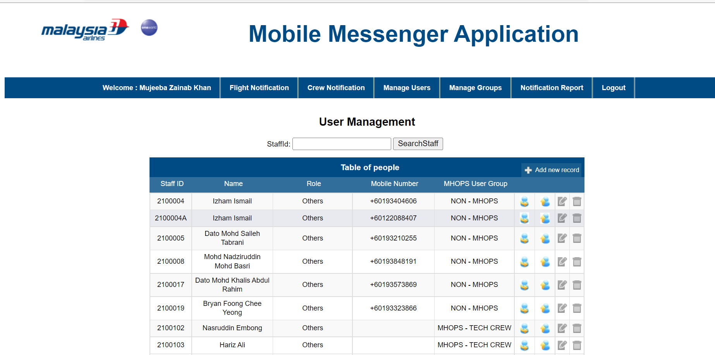

* Flight Notification Page

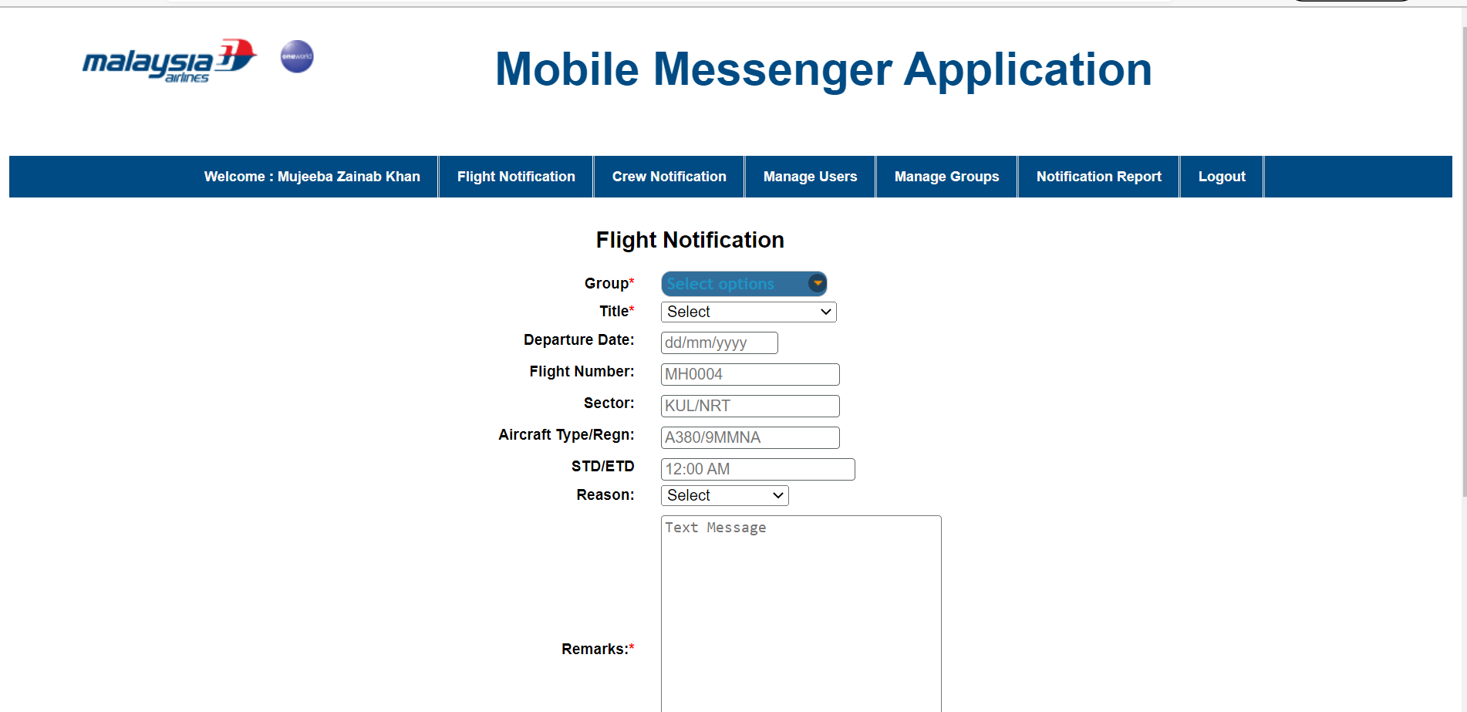

* Crew Notification page

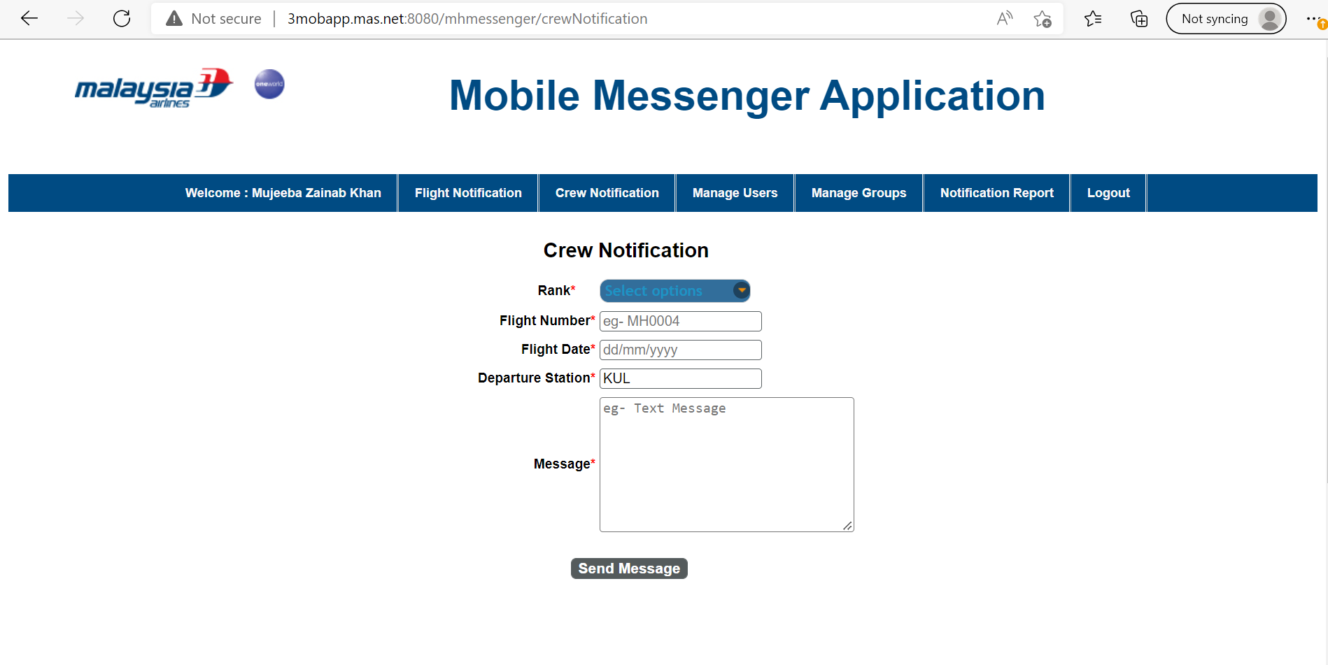

* Verify the log - Check for any unexpected error.

As you will be having the server access for this application – Check the logs with this

**ip-** 10.221.12.15

**logpath -** /tomcat/apache-tomcat/logs/MHMessenger_Log.log

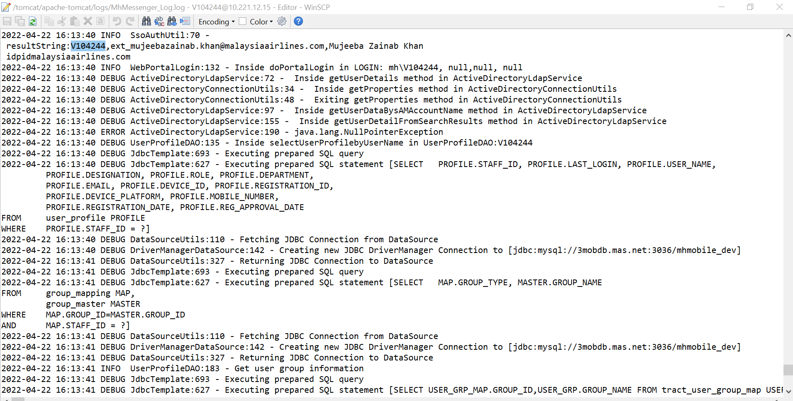

As we have validated the application and its working fine, now revert back with the same acknowledgement to that particular mail.

